Assignment 1 (Nodejs )

Create a Node.js API that reads a JSON config defining business rules for a procurement

process and applies them to input data.

Details:

Build a /processPR POST API.

Take a Purchase Requisition (PR) JSON payload as input.

Apply rules defined in a JSON file (e.g., auto-approve if value &lt; 10,000; set urgency

based on delivery date).

Return the processed PR JSON from the API response.

Sample Business Rule JSON for the API:

{

&quot;approvalRules&quot;: [

{ &quot;condition&quot;: &quot;totalAmount &lt; 10000&quot;, &quot;action&quot;: &quot;autoApprove&quot;, &quot;setStatus&quot;: &quot;Approved&quot; },

{ &quot;condition&quot;: &quot;deliveryDays &lt; 3&quot;, &quot;action&quot;: &quot;setUrgency&quot;, &quot;urgency&quot;: &quot;High&quot; }

]

}

Test1

{

"totalAmount": 5000,

"deliveryDate": "2025-07-13",

"description": "Office supplies"

}

output

{

"success": true,

"processedPR": {

"totalAmount": 5000,

"deliveryDate": "2025-07-13",

"description": "Office supplies",

"status": "Approved",

"urgency": "High",

"deliveryDays": 2

}

}

Test 2

input

{

"totalAmount": 9000,

"deliveryDate": "2025-07-20",

"description": "Office supplies"

}

Output

{

"success": true,

"processedPR": {

"totalAmount": 9000,

"deliveryDate": "2025-07-20",

"description": "Office supplies",

"status": "Approved",

"urgency": "Normal",

"deliveryDays": 9

}

}

Assignment 4: Permission-Based Data Filtering API (Nodejs)

Objective:

Build a Node.js API that applies role-based data filters.

Details:

Create an /getPRs API.

Read user role and data permissions from a JSON config:

{

&quot;role&quot;: &quot;buyer&quot;,

&quot;dataPermissions&quot;: {

&quot;allowedPlants&quot;: [&quot;PlantA&quot;, &quot;PlantB&quot;],

&quot;maxAmount&quot;: 50000

}

}

Query the PR collection and return only the allowed records.

Cache permissions in Redis.

Output

{

"success": true,

"role": "buyer",

"totalRecords": 8,

"filteredRecords": 3,

"appliedFilters": {

"allowedPlants": [

"PlantA",

"PlantB"

],

"maxAmount": 50000,

"additionalFilters": {}

},

"data": [

{

"id": 1,

"plant": "PlantA",

"amount": 25000,

"description": "Raw materials for PlantA",

"status": "pending"

},

{

"id": 2,

"plant": "PlantB",

"amount": 45000,

"description": "Equipment for PlantB",

"status": "approved"

},

{

"id": 4,

"plant": "PlantA",

"amount": 15000,

"description": "Office supplies for PlantA",

"status": "approved"

}

]

}

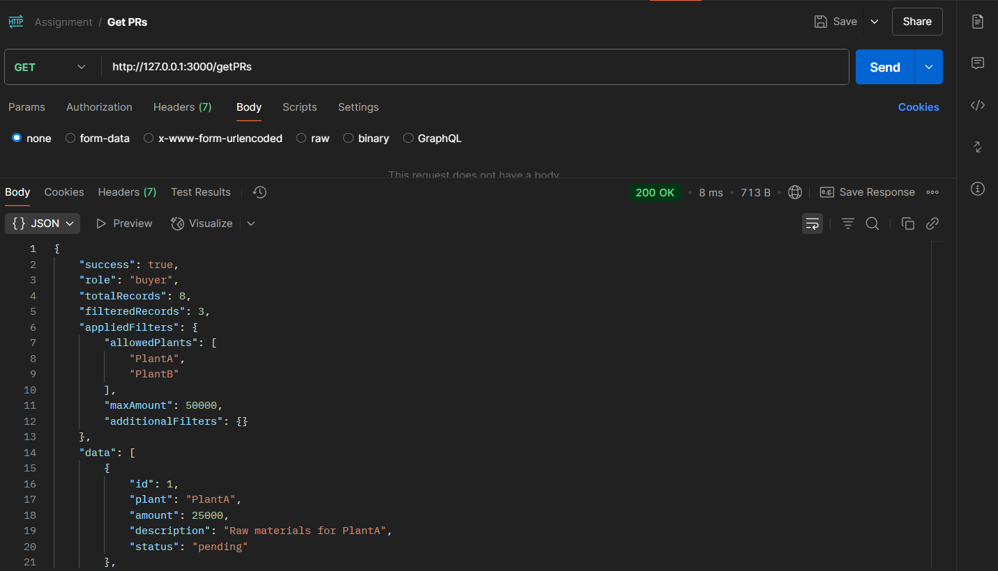

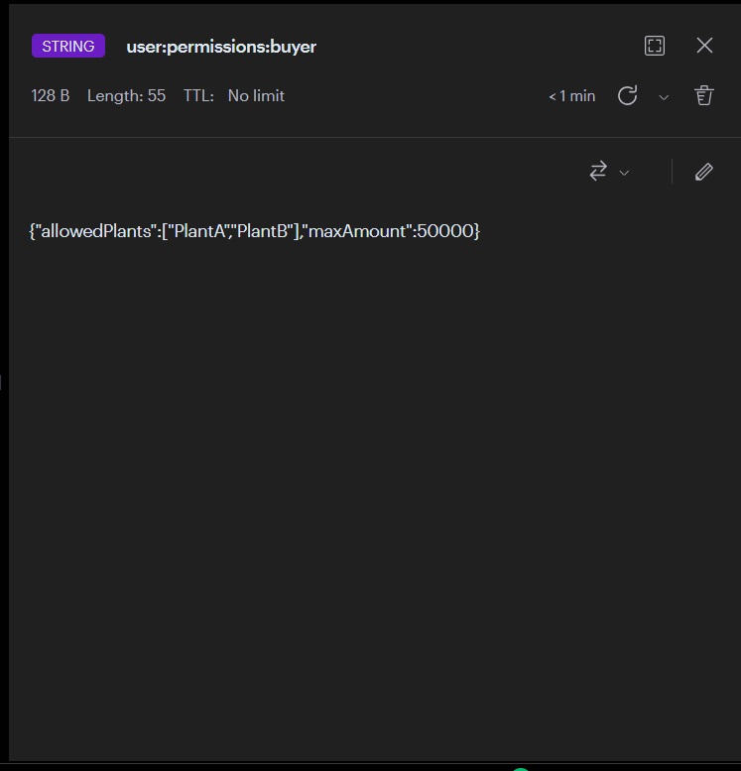

Assignment 3: Build a Python AI Microservice ( Python )

Objective:

Build a Python Flask/FastAPI microservice that summarizes a PR description using OpenAI

API (or simple text summarization library).

Details:

Expose a /summarize POST API.

Input: JSON with PR description.

Output: Summarized description.

{

"description": "This purchase requisition is raised for the procurement of 250 ergonomic office chairs for the new corporate office in Bangalore. The new chairs are intended to replace existing furniture that does not meet modern ergonomic standards, which has led to an increase in employee discomfort and reported back pain complaints. The goal is to improve workplace safety, productivity, and compliance with ISO standards. The selected vendor has been shortlisted after a competitive bidding process involving three qualified suppliers. The expected delivery timeline is 4 weeks from order confirmation, and the total estimated cost is approximately 1.2 million INR, which has been pre-approved in the quarterly procurement budget. The chairs will be distributed across five floors, with an equal number on each. Installation and quality check will be done by the vendor. This purchase is marked as high-priority due to the upcoming office launch scheduled for next month."

}

Response

{

"summary": "A purchase requisition has been raised for 250 ergonomic office chairs for the new corporate office in Bangalore to replace outdated furniture. The aim is to enhance workplace safety, productivity, and comply with ISO standards. The selected vendor was chosen through a competitive bidding"

}

